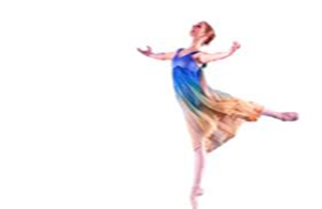
Shabahang’s Annual Talent Show

Iranian and Iranian American Youth “ages 5-18 year”

Interested to perform in declamation, music, dancing, singing

February 25, 2024

Sunday, 2.00 – 4.30pm

Rotwitt Theater

at McShane Performing Art Center, Rosemont College

1400 Montgomery Avenue, Rosemont, PA 19010

Refreshments will be served

Admission Fee: Performers: Free

Children: $10.00

Adults: $20.00

For more information and scheduling, please call (267) 838-0364

Deadline for registration: February15, 2024

