The Iranian Cultural Society of America, Shabahang
Celebrate Nowruz 1402
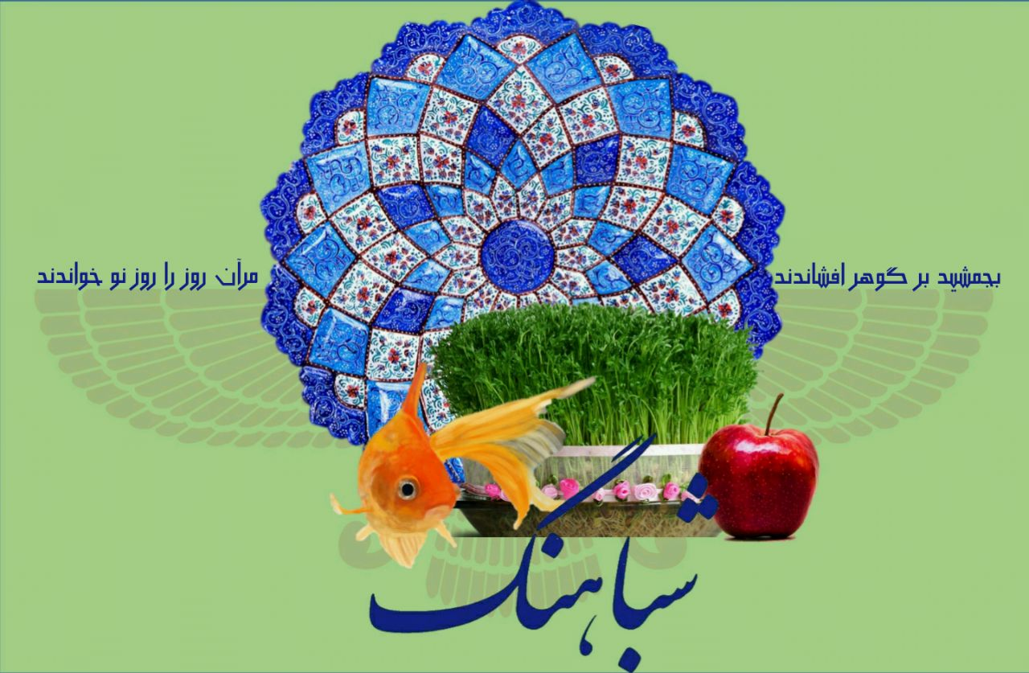
Sunday, March 19, 2023
6.00 pm to 11:00 pM
at
Springfield Country Club
400 West Sproul Road Springfield, Springfield, PA 19064

Tickets for Members: $70 Non-Members: $85 Children 5-12 years old: $40
Please provide the following information:
Name: ………………………………….. Phone No.…………………......

Number of tickets: ……. Adults members …….. Adults non-members …... Children
Check attached: $...................
Seat preference (with friends & family): ……………………………………………….
Choice of meal: ........ Chicken .............. Fish ............Vegetarian
Sabzi polo will serve with all meals.
For more information please contact: Email: habib.nayerahmadi@gmail.com
Zarin Tavakoli: (610) 353-2003 Habib Nayerahmadi: (267)254-9791 Parvaneh Khosravi: (267)205-5945

To pay by check, please make checks payable to Shabahang and mail to:
Shabahang, PO Box 148, Gladwyne, PA 19035

You Can also use your Pay Pal account and pay by Pay Pal

Deadline March 15, 2023

Note: No ticket will be sold at the door. Since the number of tickets are limited, please make sure you book your seat in advance.

