Winners of the 2021-2022 Shabahang Scholarship Awards

- Mr. Mohammad Hooshmand Khaneghahi, Ph.D. candidate, Civil Engineering, Drexel University

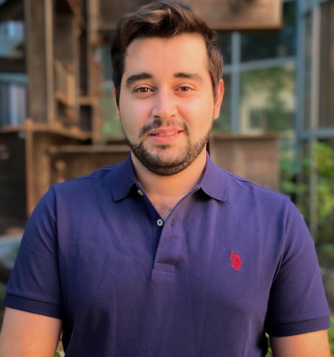

- Mr. Aria Ghahramani, MD candidate, Penn State University

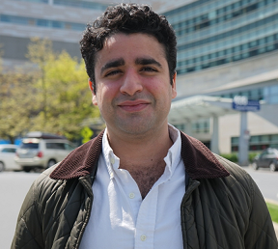

- Ms. Maryam Daniali, Ph.D. candidate, Computer sciences, Drexel university

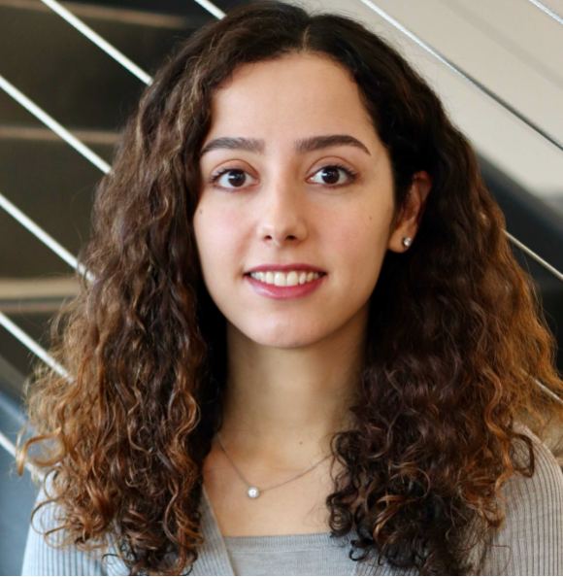

- Ms. Afrooz Mosallaeipour, Ph.D. candidate, Journalism & Media Studies, Rutgers University

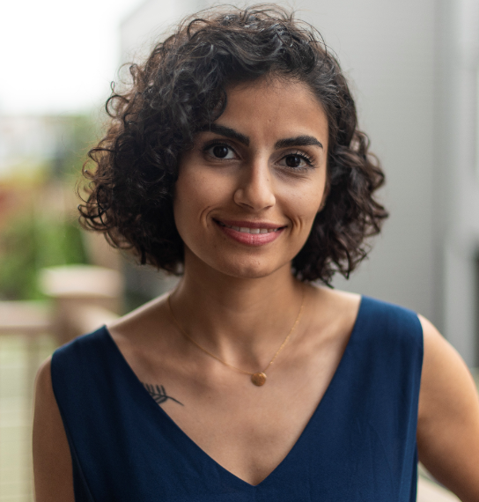

Winners at the award ceremony with Dr. Simin Dadparvar (on the left), the chair of the Scholarship Award, and Dr. Habib Nayerahmadi (on the right), the president of the Shabahang Board of Trustees

