University Student Winners

1st Prize: $1000
Narges Esfandiar
PhD candidate, Environmental engineering, Temple University
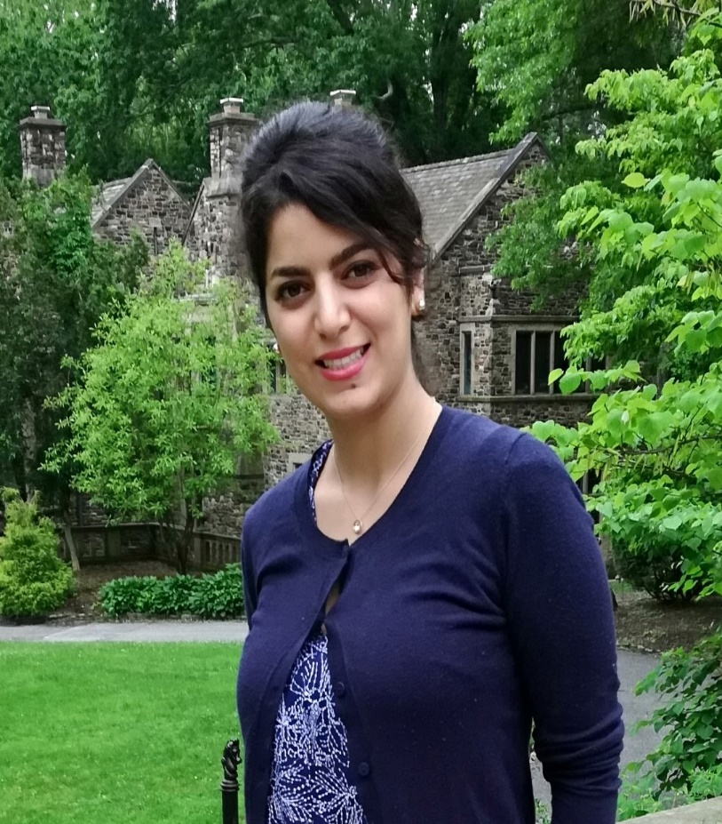

2nd Prize: $500
Behdad Chalaki
PhD candidate, Mechanical engineering, University of Delaware

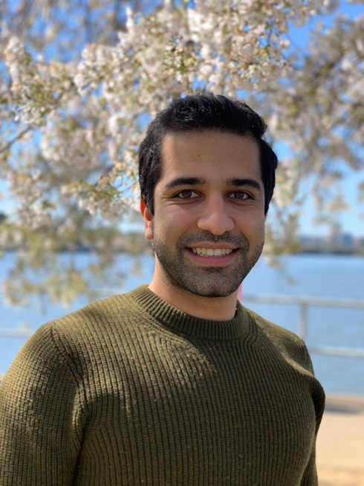

3rd Prize: $500
Negar Ghasemi
Bachelor of Music candidate, Temple University

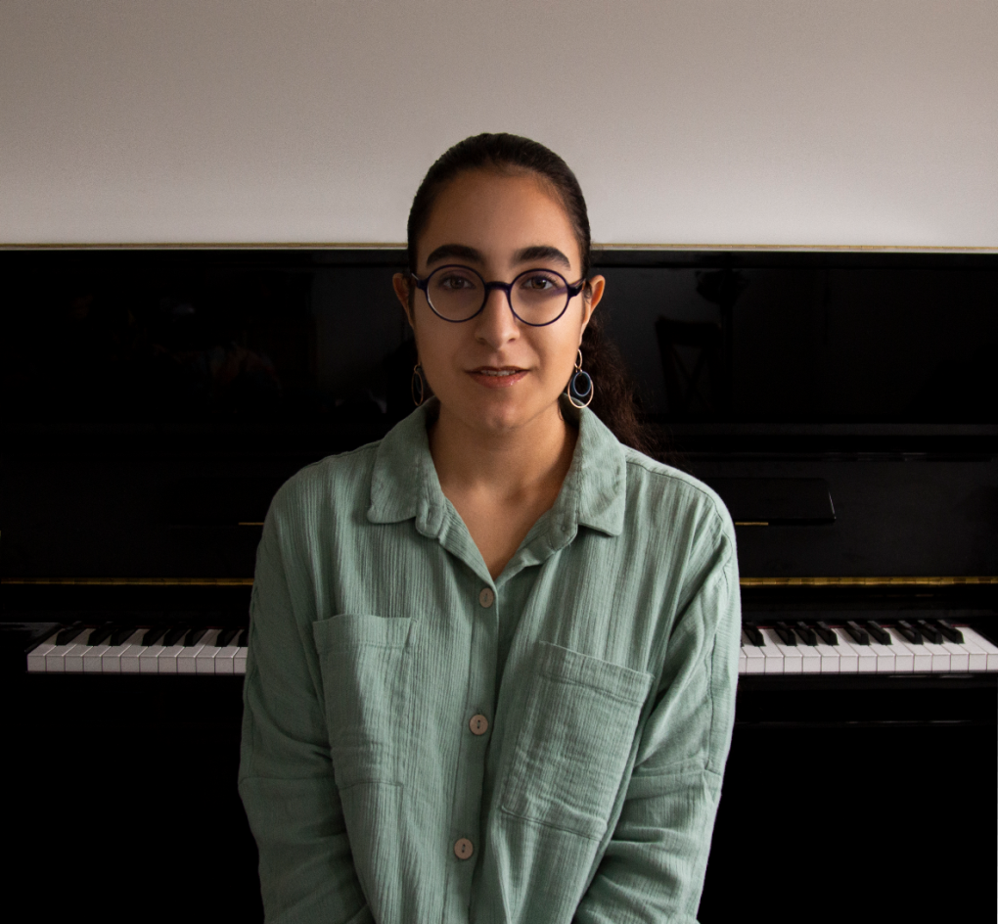

High School Student Winners
1st Prize: $150
Kiana Ahmari
Junior - Conestoga High School

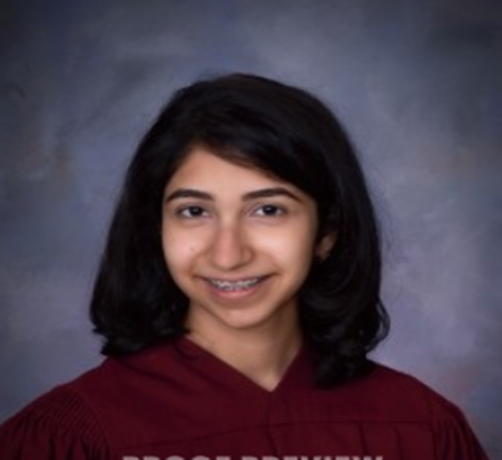

2nd Prize: $150
Paria Petramfar
Junior - Lower Merion High School

