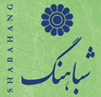
The Iranian Cultural Society of America- Shabahang
Celebrates

“ Sizdah Bedar Picnic”

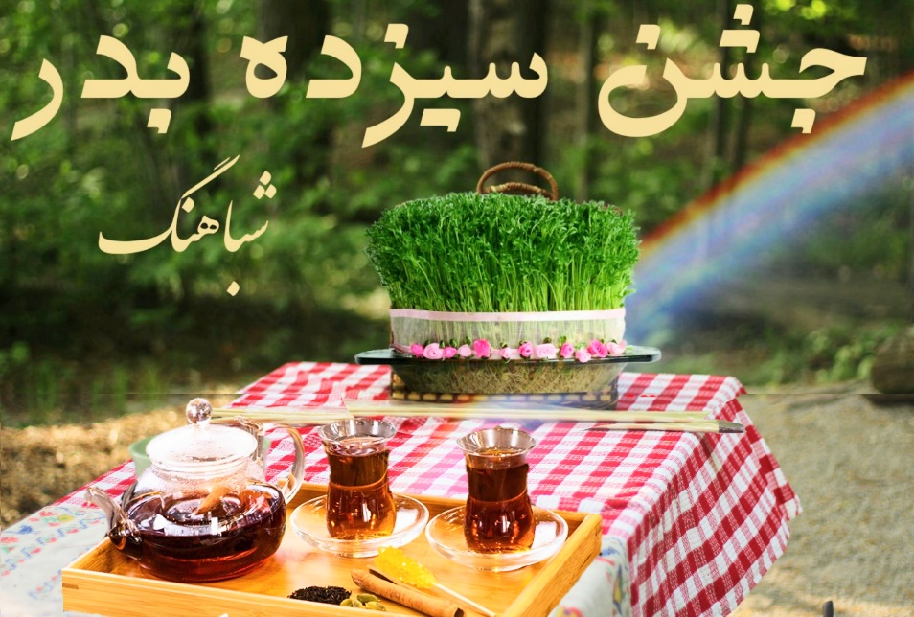
Sunday, April 7th, 2019
12:00 PM - 6:00 PM

Location: Ridley Creek State Park
Picnic Areas 11-A & 11-B
http://www.dcnr.state.pa.us/stateParks/parks/ridleycreek.aspx

Music: DJ Basha
Food: Bring your own or order by Saturday April 5 at
- Persian Grill. Customers have to pick up their orders and will get 20% discount.
(610) 825-2705 www.persiangrillusa.com
- Kabab Café (610) 975-5850. They will deliver at the park from 1:00 to 2:00 PM. www.kababcafe.com

Event ticket: $10.00 per Car
Event tickets have to be purchased by paypal at shabahang@shabahang.org, proof of purchase has to be displayed behind the front window

